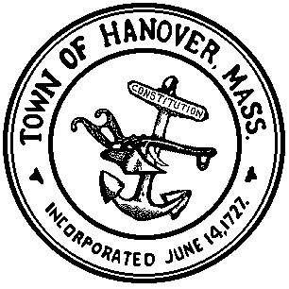
TOWN OF HANOVER
Board of Health
550 Hanover Street, Suite 17
Hanover, MA 02339
Tel: 781-826-4611
Fax: 781-826-5289

March 2019

______________________________________________________________________________

Do you have unwanted medication(s) you need to dispose of?

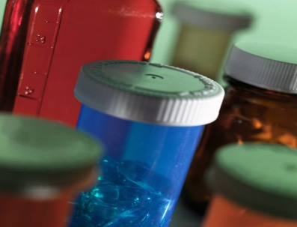

The U.S. Drug Enforcement Agency (D.E.A.) is coordinating, with the Hanover Board of Health and the Hanover Police Department, a nationwide one-day event to take back unwanted medications on Saturday, April 27, 2019 at the Hanover Senior Center, 665 Center Street, Hanover, between the hours of 10 a.m. and 1 p.m.

This national initiative will provide an opportunity for the public to surrender pharmaceutical controlled substances and other medications to law enforcement officers for destruction. Expired, unused or unwanted substances in our homes are a potential source of supply for the increasing abuse of pharmaceutical drugs in the United States and an unacceptable risk to public health and safety.

